Steps to getting a roster style print out ...Move or Copy method.
- Obtain a copy of the RstrTmplt.xlsx file and store it in a place you commonly use for your downloaded rosters.
- Download your rosters in the Excel format that includes all rosters.
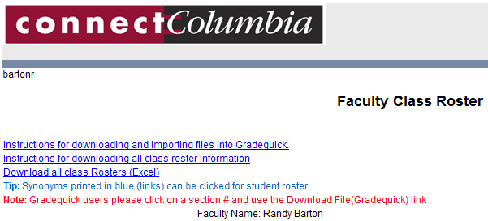
Download your files into the same place you stored the template.

- Close out of connectColumbia.
- Open the downloaded file containing your rosters. If you used Firefox to download your rosters the file may have the wrong file extension. If your file looks like “xls_xml_test.aspx” rename it to xls_xml_test.xls before you continue. You may also see the following warning when opening your roster, go ahead and click yes to open your roster

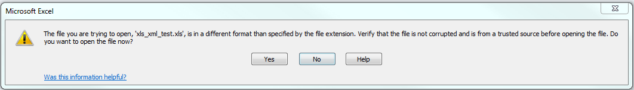

- Open the RstrTmplt.xlsx file. Both will be open at the same time.
- Right click on the sheet tab (at the bottom) of the template and choose to Move or Copy.
- From the To book drop down, choose your file that was downloaded and also check the Create a copy checkbox.

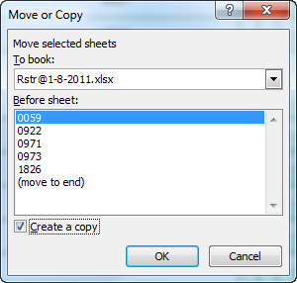
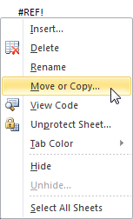
Choose to Create a copy.
Click drop down and select the downloaded file.

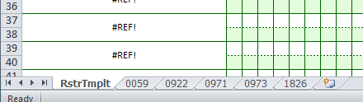
- You should now have a copy of the RstrTmplt in your Workbook with your downloaded roster data. Click the Save button.

Section numbers used in Step 9

- To get a roster style print out, go to the top of the template and fill in the section number (just as you see it on the sheet tab at the bottom) for a class.
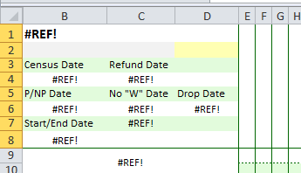
Fill in the Section number in the Yellow Box. Instructor name in the Grey Box

- Type in any column information you like.
- When printing, tell it 1 page if you only need the first page (defaults to 2).
- You can also rename the sheet tab to whatever you want and keep it. Use the steps for copying a sheet to make multiple copies of the template in the workbook. It is important that the downloaded sections remain in the workbook because they are the templates data source. (They can be hidden if you like)

